Why Docker is better than Virtual Machines:
- Lightweight:
  - Docker shares the host OS kernel, so it uses fewer resources.
  - VMs need a full OS, which makes them heavy.
- Faster Startup:
  - Containers start in seconds.
  - VMs take minutes to boot because of the full OS.
- Efficiency:
  - Docker can run many containers using less RAM and CPU.
  - VMs require more resources per instance.
- Portability:
  - Docker works the same across all environments (dev, test, production).
  - VMs may face compatibility issues due to OS differences.
- Easier Scaling:
  - Docker can quickly spin up or down containers.
  - VMs take longer to replicate or scale.
- Better DevOps Integration:
  - Docker works seamlessly with CI/CD pipelines and microservices.

Not exactly! A container is not a full OS; it’s just an isolated environment that runs on the host OS kernel.
Here’s why it’s lightweight:
- Containers reuse the host OS kernel, so they don’t need their own kernel or full OS.
- They include only the app’s code, dependencies, and minimal runtime.
VMs, on the other hand:
- Have a complete OS, including its own kernel, which takes more space and resources.
That’s why containers are faster, lighter, and more efficient than VMs!

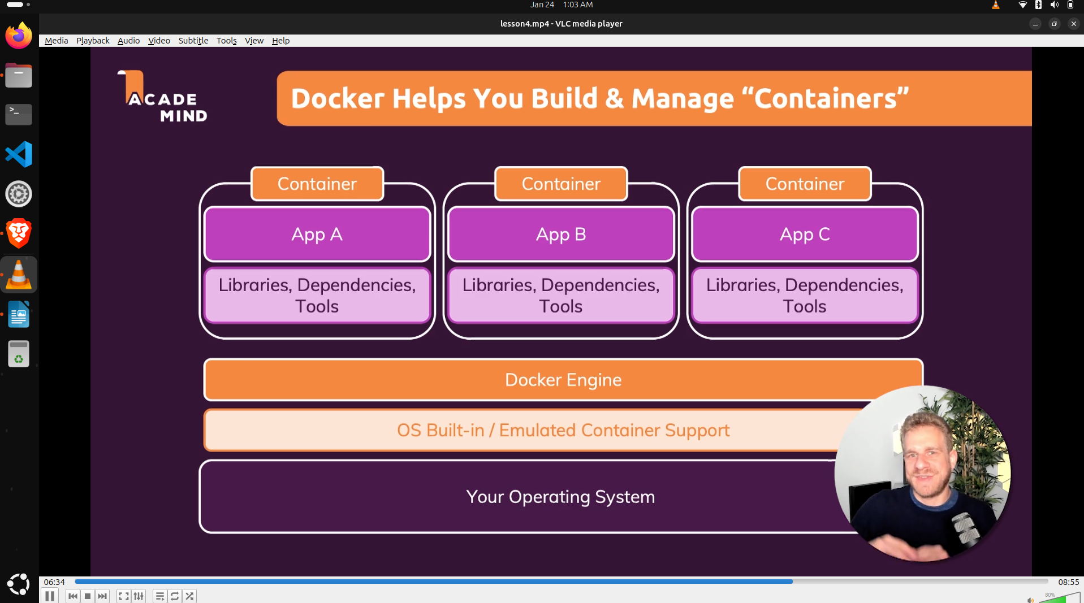
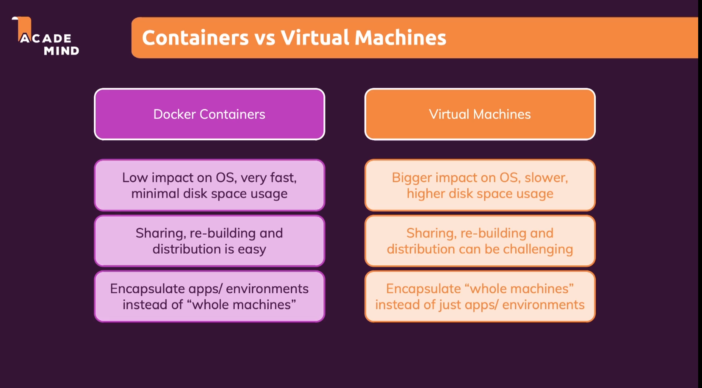

1. Docker Engine
Docker Engine ek software hai jo Docker containers ko chalata hai. Yeh ek background service hai jo containers ko create, run, aur manage karta hai.
- Kaam: Containers ko run karne aur manage karne ke liye responsible hota hai.
- Components: Docker Daemon (background process) aur Docker CLI (command-line interface) jo aap command prompt ya terminal se use karte ho.

2. Docker Desktop
Docker Desktop ek GUI (Graphical User Interface) application hai jo Windows aur Mac users ke liye hai. Isme aapko Docker Engine, Docker Compose, aur Docker Hub ke integration ka access milta hai ek simple interface ke through.
- Kaam: Easily Docker containers ko GUI ke through manage karne ka option deta hai.
- Features:
  - Visual Interface
  - Docker Hub integration
  - Kubernetes support (optional)
  - Easy installation aur configuration

3. Docker Hub
Docker Hub ek cloud-based registry hai jahan aap Docker images ko store aur share kar sakte ho. Yaha pe official aur user-created Docker images milti hain.
- Kaam: Docker images ko store, share, aur download karne ka platform.
- Example: Agar aapko ek Node.js app run karna hai, toh aap Docker Hub se Node.js image pull kar sakte ho.

4. Docker Compose
Docker Compose ek tool hai jo multiple Docker containers ko ek saath manage karne mein madad karta hai. Aap docker-compose.yml file ke through define kar sakte ho ki kaunse containers chalenge aur unka configuration kya hoga.
- Kaam: Ek configuration file ke through multiple containers ko manage karna.
- Example: Agar aapko ek web server aur database ke containers ko ek saath run karna hai, toh Docker Compose use karke aap dono ko ek saath configure aur start kar sakte ho.

Summary:
- Docker Engine: Containers ko run karne ka engine.
- Docker Desktop: GUI interface for managing Docker on Windows/Mac.
- Docker Hub: Cloud registry for storing and sharing Docker images.
- Docker Compose: Multiple Docker containers ko ek saath manage karne ka tool.
